ENERGY
1. (a) Place the following types of energy into their correct group:

chemical heat light gravitational electrical sound elastic kinetic

Potential (stored) energy | Active energy

(b) Choose ONE type of energy from the potential energy group and ONE from the active energy group (above) and for each describe:
- Where the energy is found (in which substances)
- What types of energy it can be transformed into.

2. Write energy equations for the following scenarios:
(a) A computer starts up.

(b) A person rides a bike.

(c) An electric light comes on.

3. Explain the law of energy conservation.

4. Using the Venn diagram below show the differences and similarities of coal and wood as fuel sources.

Standard Hokey Pokey Ice cream Low Fat Ice cream

Nutrition information
Serving size 100g.
 | Per serve
Energy | 827 kJ
Fat | 9.3
Carbohydrate | 25.0
-sugars | 25.0
Protein | 2.9
Nutrition information
Serving size 100g.
 | Per serve
Energy | 848 kJ
Fat | 3.0
Carbohydrate | 38.0
-sugars | 27.0
Protein | 5.2

5. Above are food labels comparing hokey pokey ice cream and low fat ice cream.
(a) State how much energy in kilojoules is provided per serving for both types of ice cream.
Hokey pokey : Low fat:

(b) Sunny usually jogs for 30 minutes a day. He uses 75 kJ of energy per minute of jogging.

(i) Calculate how much energy he uses in the 30 minutes.

(ii) Calculate how many servings of the low fat ice cream he will need to eat to provide him with the energy he needs for his run.

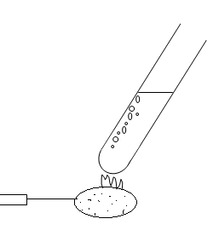
6. A corn chip was burnt to see how much energy was contained in just one chip.

(a) State the form of energy that is contained in the corn chip.
Corn chip

(b) In the box below write the equation for the energy changes happening as the corn chip burns.

(c) The corn chip takes 28 seconds to burn. The mass of water in the test tube is 20 grams. The water temperature rises from 20°C to 80°C. Using the following equation, calculate how much energy was in the corn chip.

Energy (Joules) = mass of water x temperature change x 4.18 J g⁻¹°C⁻¹

(d) Sunny’s friend uses 80 kJ per minute when running. Calculate how many corn chips would be needed to provide the energy for a 30 minute run.

7. 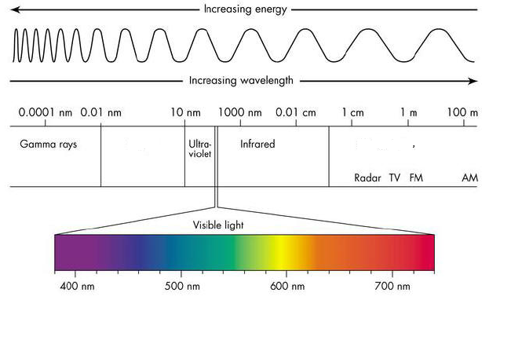
A
B
(a) Label the parts A and B on the electromagnetic spectrum.
A: B:

(b) Underneath the visible light part of the diagram, show approximately where each of the seven colours would appear.

(c) Choose ONE of the types of electromagnetic radiation from above and:
- State the source (where it comes from)
- Explain if it is helpful or harmful and how it effects humans

