ELECTRICITY
1. Kelsey loves to bounce on her trampoline on sunny days. After bouncing for several minutes her hair sticks up on end.
(a) Name the type of electricity that causes her hair to stick up.

(b) Name the force that causes this type of electricity to build up as Kelsey moves around on the trampoline.

(c) Discuss why Kelsey’s hair begins to stick up.

(d) When Kelsey’s sister also gets onto the trampoline, Kelsey likes to give her a small electric shock by touching her hand. Explain why this happens.

(e) Kelsey’s sister says that it is similar to a bolt of lightning.
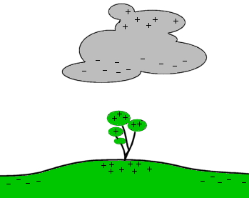
(i) On the diagram, draw where a lightning bolt is most likely to occur.
(ii) Use the diagram to explain what causes lightning.

2. (a) (i) Describe what is meant by an electrical conductor.

(ii) Give an example of a substance that can be used as an electrical conductor.

(b) (i) Describe what is meant by an electrical insulator.

(ii) Give an example of a substance that can be used as an electrical insulator.

3. In the spaces below draw circuit diagrams, using the correct symbols for:
(a) A single cell for the power supply, connected to a resistor and a bulb in series. There is a voltmeter measuring the voltage of the bulb.

(b) A 9 volt battery connected to two bulbs. There are two switches, so that each bulb can be turned on or off without affecting the other bulb. There is an ammeter to measure the total current of the circuit.

4. Compare the two circuits below. All the bulbs are identical.
12 V
Circuit A
. . .
12 V
Circuit B
. . .

(a) State which of the circuits has the bulbs wired in series.
(b) State which of the two circuits would have the brightest bulb. Give a reason for your answer.

(c) For each of the two circuits, explain what would happen to the remaining bulb if one bulb ‘blew’.
Circuit A:
Circuit B:

5. (a) Explain what is meant by the term electrical ‘resistance’.

(b) Describe one factor that would increase the resistance of a wire.

(c) Explain what a variable resistor (rheostat) does, and give two examples of how variable resistors are used in the home.

6. The circuit below was set up and some current and voltage readings were taken.
12 V
. . .
X

(a) Add the correct symbol to the empty circles to represent the ammeter and voltmeter.
(b) Explain what the voltmeter measures.

(c) State the reading that would appear on the voltmeter. Include the units.

(d) Discuss what the ammeter measures. Include the units that it measures in.

(e) Explain how the reading on the ammeter would change (would it decrease or increase) if the ammeter was moved to the position marked X.
Increase or Decrease:
Explanation:

7. Fuses are very important circuit components.
Fuse symbol:
(a) In the box, draw the circuit symbol for a fuse.
(b) Discuss why fuses are so important.
In your answer include an explanation of:
    - The purpose of a fuse
    - How a fuse works
    - Possible problems if a circuit does not have a fuse.

