WORKSHEET TWO Infrared spectroscopy
1. State the main aim of infrared spectroscopy.

These values are approximate and peaks may be slightly above or below these values.
Bond | Types of compound | Range/ cm⁻¹
C-H | Alkanes, Alkenes, Aldehydes | 3100-2800
O-H | Alcohol | 3700-3300
 | Carboxylic acid | 3600-2500 broad
N-H | Amine | 3500-3100 sharp
C-O | Alcohols, carboxylic acids, esters | 1250-1050
C=O | Aldehydes, ketones, carboxylic acids, esters | 1850-1600
C=C | Alkenes | 1500-1600
C-Cl | Chloroalkane | 600-800
C-Br | Bromoalkane | 500-600
C-I | Iodoalkane | 500

2. List the compounds which may show absorbance in the following ranges:
3400-3600 cm⁻¹
1300-1700 cm⁻¹

3. Explain how an infrared spectrum of a carboxylic acid would differ to an ester.

4. Name the functional group in each of the following pairs of compounds. Indicate the absorption range that would allow for each pair to be differentiated using infrared spectroscopy. (Use the chart above for absorption ranges.)
(a) Ethanol and ethene.
Functional groups:
Absorption ranges:

(b) Propanoic acid and propanal.
Functional groups:
Absorption ranges:

(c) 1-aminobutane and butan-2-one.
Functional groups:
Absorption ranges:

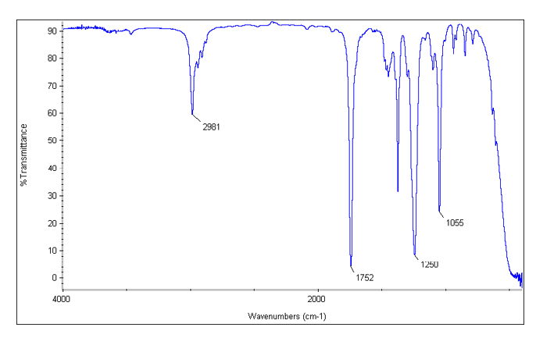
5. (a) Circle the compound below (a-d) that matches the above spectrum.
a. CH₃CH₂Cl
b. CH₃CH₂NH₂
c. CH₃CH₂OH
d. CH₃CO₂CH₃
(b) Explain your choice above.

6.
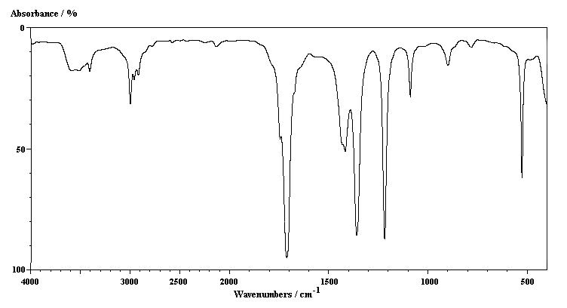
The spectrum above is either of a ketone or a carboxylic acid. Using the correlation chart, assign the various peaks and explain which compound is most likely from the two choices.

